**5.1 REVERESE ENGINEERING AND MALWARE ANALYSIS**

Shubhash s

Roopkatha pradhan

Gitesh bhavsar

Shreya dokania

**REVERSING MOBILE APPLICATION**

We took a simple mobile application which will print whether the given user is VIP user or not. In this application there is only one VIP user whose username is “sabin”. We going to reverse engineer it and make it available for everyone.

“Dex-2-jar” is a opensource tool to covert Dex file into jar file.

Viewing the jar file in JD decompiler which only readable not writeable

In this code we have to change the return value in the Boolean i() function so that it always return true so that everyone is VIP user.

To modify reversed code we need to use apktool



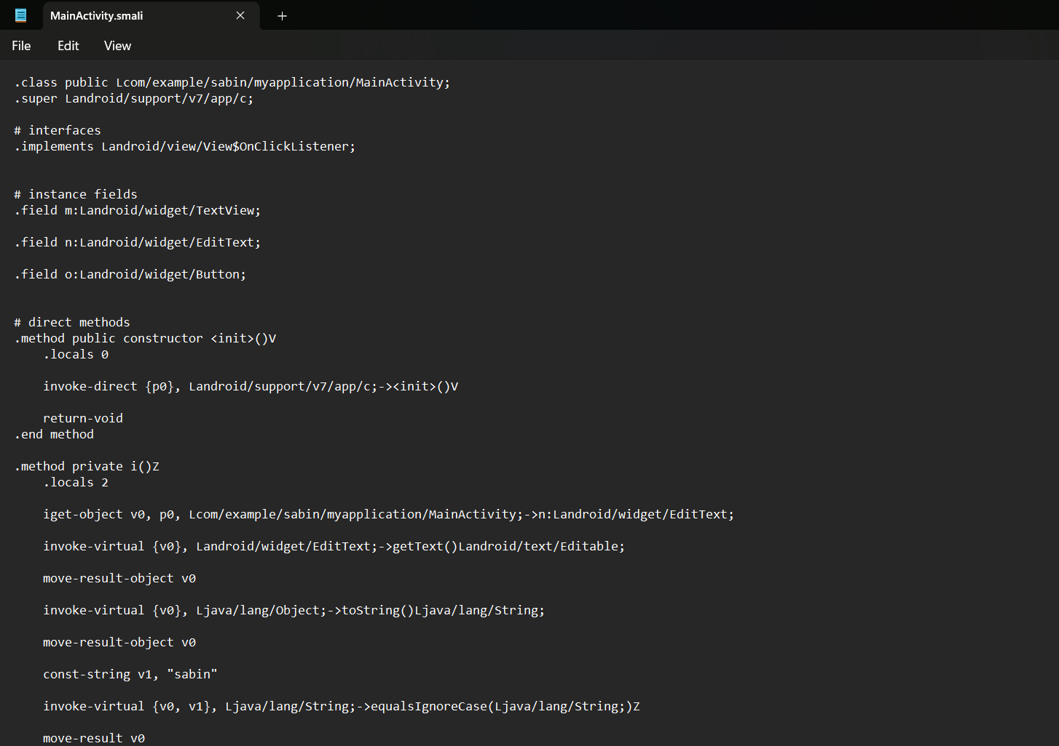

In this reversed code we found the i() function

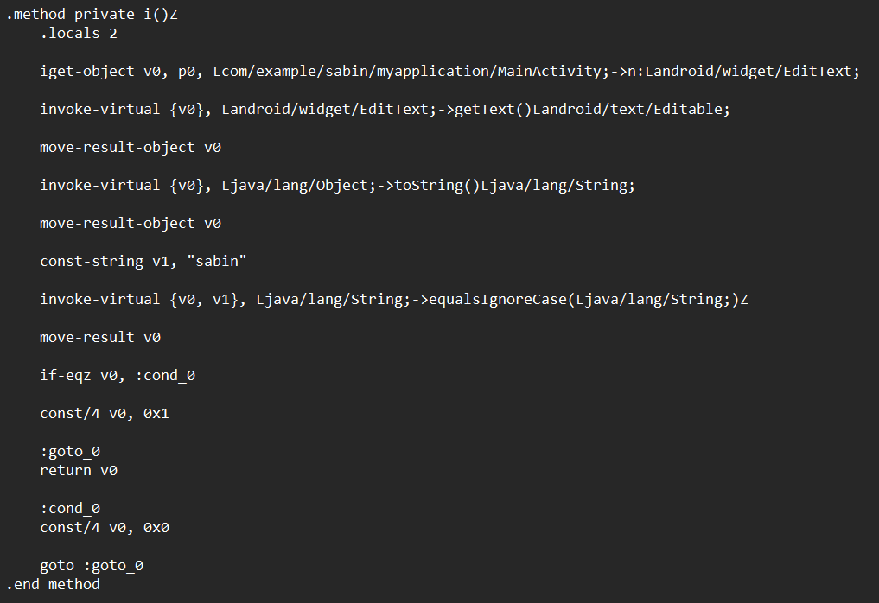

At bottom we found the if-else statement and the variable “V0” is used to return the true/false. So we need to change it as 1 which is always true.

Now we have made the APK with our modified code



Now final step we need to sign the APK using keytool and jarsigner,

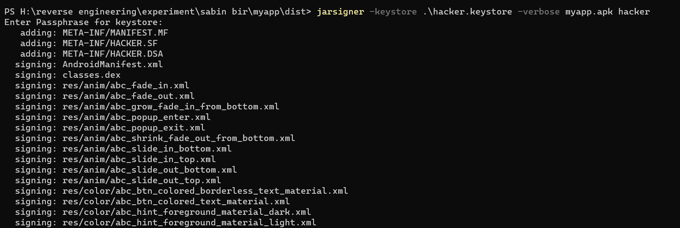

**CONCLUSION:**

We have successfully reverse engineered and modified the app now every user is VIP user.